Smart Parking Guide: A Solution for Dyslexia-Related Challenges

Eitika Sharma
202352860
MSc Data Analytics (Sept’23)

Declaration

Except where explicitly stated, all the work in this dissertation – including any appendices – is my own and was carried out by me during my MSc course. It has not been submitted for assessment in any other context.

Signature: Eitika Sharma
Date: 26/08/2024

Summary

The project, titled "Smart Parking Guide: A Solution for Dyslexia-Related Challenges," addresses a significant and often overlooked issue faced by individuals with dyslexia—interpreting complex parking signs. This project aims to develop a mobile application that leverages machine learning to assist dyslexic drivers in understanding parking signs more effectively, thereby reducing the stress and potential fines associated with parking violations.
The motivation for this project stems from the recognition that existing assistive technologies for dyslexic individuals focus primarily on reading and writing, leaving a gap in tools that address visual interpretation challenges. The project's primary goal is to create a smart parking guide that can interpret parking signs in real-time, providing clear and accessible information to dyslexic users. This will involve developing a machine learning model trained to recognize various types of parking signs and integrating it into a user-friendly mobile application.
The project is structured around several key objectives: identifying the specific challenges dyslexic individuals face with parking signs, developing a robust machine learning model, and designing an intuitive mobile application. The research phase involved a comprehensive literature review and user surveys to understand the difficulties faced by dyslexic drivers. The data collected informed the design and functionality of the application, ensuring it meets the needs of its target audience.
The machine learning model was developed using a dataset of parking sign images, which was augmented to improve the model's ability to generalize across different conditions. The application was then built using React Native, ensuring cross-platform compatibility and incorporating feature such as text-based interpretations of parking signs.
The project concludes that while the smart parking guide represents a significant step forward in addressing the needs of dyslexic drivers, there is still room for improvement. Future work will focus on enhancing the model's accuracy, integrating additional features such as GPS navigation, and expanding the app's capabilities to cover more types of parking signs. The ultimate goal is to create a comprehensive tool that not only helps dyslexic individuals with parking but also contributes to broader efforts to make urban environments more accessible and inclusive.

Acknowledgement

I would like to extend my deepest gratitude to everyone who contributed to the successful completion of this project, Smart Parking Guide: A Solution for Dyslexia-Related Challenges.
First and foremost, I would like to thank my academic supervisor, Dr. Muhammad Irfan, for his invaluable guidance, support, and encouragement throughout the course of this research. His insights and expertise have been instrumental in shaping this project.
I am also immensely grateful to the Strathclyde Business School for providing me with the resources, environment, and unwavering support necessary not only to conduct this research but also to achieve my academic goals and complete my master's degree. The opportunity to work on this project has been an invaluable learning experience, allowing me to contribute to society by addressing the challenges faced by dyslexic individuals in understanding parking signs. I am deeply appreciative of the role the institution has played in my academic journey and in enabling me to tackle this important issue.
Special thanks to the participants who took part in the study and provided feedback that was crucial in refining the mobile application. Their willingness to engage with the project has helped to ensure that the solution developed is both practical and effective.
Lastly, I would like to express my heartfelt appreciation to my family and friends for their continuous support and encouragement throughout this journey. Their belief in me has been a source of strength during the most challenging times.
Thank you all for your contributions to this project and for helping me reach this important milestone in my life, while also contributing to a meaningful cause.

Table of Contents
Declaration ii
Summary iii
Acknowledgement iv
CHAPTER 1: Project Context 0
1.1 Background and Motivation 1
1.2 Problem Statement 2
1.3 Aim and Objective of the Project 3
1.3.1 Research Questions 3
1.4 Contingency Plans & Limitations 5
1.4.1 Data Collection 5
1.4.2 Model Performance 6
1.4.3 Technological Impediments 7
1.4.4 User Adoption and Acceptance 8
1.4.5 Legal and Ethical Concerns 9
1.5 Project Plan 10
CHAPTER 2: CLIENT REPORT 12
Acknowledgement 1
Executive Summary 2
2.1 Introduction 3
2.2 Literature Review 4
2.2.1 Dyslexia in the UK: Its Prevalence and Impact 4
2.2.2 Navigating the UK's Urban Landscape with Dyslexia 4
2.2.3 UK Parking Regulations and Dyslexia 4
2.2.4 Assistive Technologies for Dyslexic Individuals in the UK 5
2.2.5 Image Recognition Technologies and UK Urban Environments 5
2.2.6 Smart Cities and Accessibility in the UK 5
2.2.7 Legislation and Help in the UK for People with Dyslexia 5
2.2.8 UK Research on Cognitive Processing and Visual Information 6
2.2.9 Technology Adoption for Dyslexic Adults in the UK 6
2.2.10 Economic Impact of Parking Challenges among Dyslexic people 6
2.2.11 User-Centered Design for Dyslexic People in the UK 6
2.2.12 Potential Integration with Existing UK Parking Systems 7
Gap Analysis 7
2.3 Methodology 8
2.3.1 Data Analysis 8
2.3.1.1 Demographic Insights 8
1. Age and Gender Distribution: 8
2. Education Level: 9
2.3.1.2 Driving Experience 10
1.Driving Prevalence: 10
2.Driving Experience: 11
2.3.1.3 Challenges with Parking Signs 13
2.3.1.4 Feedback on Proposed System: 13
2.3.2 Mobile Application Development 15
2.3.2.1 Model building 16
2.3.2.1.1 Data Collection 16
2.3.2.1.2 Data Preparation 16
2.3.2.1.3 Importing Required Libraries 17
2.3.2.1.4 Setting Up the Pre-Trained Model 17
2.3.2.1.5 Customizing the Model 17
2.3.2.1.6 Compiling the Model 18
2.3.2.1.7 Training the Model 18
2.3.2.1.8 Saving the Model 19
Significance for Model Training 19
2.3.2.2 App Development 19
2.3.2.2.1 Model Conversion 20
2.3.2.2.2 Setting Up the Navigation Structure (App.tsx) 21
i. Defining the Navigation Flow 21
ii. Navigation Container and Stack Navigator 21
2.3.2.2.3 Home Screen Interface and User Interaction (HomeScreen.tsx) 21
i. Home Screen 21
ii. Instruction Screen 22
2.3.2.2.4 Capturing and Analyzing Images (CameraScreen.tsx) 23
i. Loading the Machine Learning Model 23
ii. Capturing an Image 24
iii. Processing the Image 25
• Compression: 25
• Conversion to Tensor: 25
• Prediction by Model 25
iv. Analyzing the Prediction 25
• Time-Based Restrictions: 26
• Permit Requirements: 26
v. Displaying the Results 26
2.4 Results and Findings 27
2.5 Future Scope of Improvement 29
2.5.1. Improving Model Accuracy 29
2.5.2. Integrating Permit Holding Information at Registration 29
2.5.3. User Interface (UI) Improvements 29
2.5.4. Including a Zoom Feature 29
2.5.5. Expanding Sign Recognition Capabilities 30
2.5.6. Implementing Audio-Based Output 30
2.5.7 Improving Image Input Validation 30
2.5.8 Educational Module for Users with Dyslexia 30
2.6 Conclusion 31
2.7 References - 1 -
2.8 Appendices - 4 -
2.8.1 MS Form Responses - 4 -
2.8.2 Code for Model build - 6 -
2.8.4 JSON Model File - 8 -
2.8.5 Five shard bin files - 8 -
2.8.3 Mobile App Code Link - 8 -
2.8.4 Parking Sign Analysis - 9 -

List Of Figures and Tables

Figure 1: Project Plan 11
Figure 2: Age Group Distribution 9
Figure 3: Gender Distribution 9
Figure 4: Education Level Distribution 10
Figure 5: Driving Prevalence Distribution 10
Figure 6: Distribution of Valid Driving License Holders 11
Figure 7: Distribution of Driving Experience 11
Figure 8: Corelation Heatmap of Adjustments requested 12
Figure 9: Most Challenging Elements of Parking Signs 13
Figure 10: Likelihood of Using Smart Parking App 14
Figure 11: Preferred Features for App 14
Figure 12: Importance of real-time updates on parking restrictions 15
Figure 13: Additional Functionalities in App 15
Figure 14: Dataset 17
Figure 15: Training epoch results 19
Figure 16: Model Conversion 20
Figure 17: 3 Key files 21
Figure 18: Home Screen 22
Figure 19: Instruction Screen 23
Figure 20: Model Loading Screen 24
Figure 21: Grant Permission Screen 24
Figure 22: Camera Screen 25
Figure 23: Analyzing Screen 25
Figure 24: Result Screen 26

CHAPTER 1: Project Context

Background and Motivation

Imagine trying to read a book where the letters seem to dance around on the page. That's a bit like what people with dyslexia experience every day. Dyslexia isn't just about struggling with reading in school - it can make everyday tasks like understanding road signs a real challenge.
Now, picture yourself driving through a busy city, desperately searching for a parking spot. You finally find one, but there's a confusing mess of parking signs. For most of us, it's annoying. But for someone with dyslexia, it can be downright overwhelming. Those signs, with their jumble of words, numbers, and symbols, might as well be written in a foreign language.
This stress isn't just a minor inconvenience. It can lead to parking tickets, fines, and a whole lot of anxiety. Some people with dyslexia might even avoid driving to certain areas altogether, missing out on job opportunities or social events.
That's where this project comes in. Smart Parking Guide isn't just an app - it's a lifeline for dyslexic drivers. Imagine having a friendly voice in your pocket that can look at those confusing signs and tell you, in plain language, whether you can park there or not. It's about more than avoiding fines; it's about giving people the confidence to explore their cities without fear.
By reducing the stress of parking, this project hopes to open up new opportunities and experiences for individuals with dyslexia. It's about independence, it's about inclusion, and ultimately, it's about making cities truly accessible to everyone.

1.2 Problem Statement

The core problem in this project is based on the difficulty that dyslexics feel in having to interpret parking signs. Usually, these parking signs comprise of, all in one, some text, symbols and timing regulations which require being understood while making a quick maneuver so as to avoid the instances of receiving tickets for parking wrongly. A dyslexic, as he would generally find reading and visual processing difficult, would consider this task very intimidating.
That means the difficulty in understanding the parking signs, very complicated and variable; differences could be found going from one city to another and even inside a single city. This inconsistency in the rules creates difficulty for the dyslexic driver to develop any surefire strategy in reading; thus, often he misreads the signs.
This problem is significant in the sense that dyslexics will panic if they have received fines for parking offenses they did not even intend to commit, mostly bringing financial pressures and a lack of confidence while driving. This can make them avoid driving altogether because of the anxiety of parking, thus limiting mobility and independence.
The situation is worsened by the fact that no specifically designed solutions exist for these challenges. There exists general assistive technology for dyslexia in the form of text-to-speech applications, but there is a glaring lack of tools that would facilitate the interpretation of visual information, such as parking signs. This can be bridged by developing a smart parking guide that would support drivers suffering from dyslexia with image recognition and real-time information delivery.

1.3 Aim and Objective of the Project

This project looks towards the development of a smart parking guide application that uses a mobile device to accurately help the dyslexic make meaning out of parking signs in real-time. The proposed solution, when fleshed out, will use machine learning and mobile technology to realize an intervention that is both user-friendly for ease of application and also promotes accessibility while lowering the burdens involved in parking for a dyslexic driver.
The specific objectives of the project are listed below:
Objective 1: Identification of challenges that a dyslexic person may encounter when interpreting parking signs
The literature review and user research will be performed about how and to what extent a dyslexic person struggles with interpreting parking signs. Gained insights from the research will guide the design and features of the smart parking guide.
Objective 2: Develop a machine learning model to recognize and interpret parking signs.
The program will handle the collection of a dataset of parking signs and how it can be curated. Then, it will train a machine learning model to view and analyze correctly; the model must cater to the various types of signs that are inclusive of text, symbols, and time-based regulations.
Objective 3: Implement the model into the user-friendly mobile app that will deliver real-time parking guidance.
The application is going to be accessible for dyslexic people, which means it will have clear text, audio description, and an understandable view and interface. Basically, the trained machine learning model will analyze images of the parking signs taken by the user and provide real-time, crystal-clear guidance on whether it is appropriate to park there.

1.3.1 Research Questions
The research questions that will be explored through the proposed project are:
Q1: What are the prevalent issues related to understanding parking signs that a dyslexic person may encounter?
That is, what aspects of parking signs, whether it be text complexity, interpretation of symbols, time-based rules, etc. pose a challenge for the dyslexic population?
Q2: How can machine learning models actually be trained to correctly identify and interpret a wide range of parking signs?
This question looks into the technical aspect of the project with regard to recommended practices that should be implemented in training a machine learning model so that it can accurately recognize a wide variation of parking signs.
Q3: What are best practices in designing a mobile application that should communicate parking information effectively to users who are dyslexic?
This question targets the user interface and user experience design of the app, guaranteeing that the final product is accessible and user-friendly to the dyslexic.
Q4: In what ways is the experience of dyslexic persons in urban parking scenarios different because of using this kind of application?
This will be ensured through user testing, using questions that check whether the application decreases, as expected, parking-related stress and enhances compliance with the rules of parking.

1.4 Contingency Plans & Limitations

In the process of going through any complex project, especially one dealing with technological development and user experience considerations, the realization of potential risks and challenges occurring in the course of project execution becomes important so that there can be proper availability of mitigation plans and an approach to cover up. This section describes the most relevant risks for the "Smart Parking Guide" project and related contingency plans in order to deal with it. All this preparation in advance will make sure that the disturbance is kept to the minimum, thus facilitating the complete project.

1.4.1 Data Collection
Risk:
The effectiveness of the Smart Parking Guide is dependent on the availability and the quality of parking sign images—required for the training of the machine learning model. If the data collected is sparse or not very diverse in some dimensions (like varieties of signs and environmental conditions), the model may not work well over the real world, and it will have a spillover impact on the interpretation of parking signs, which in turn will make the app less effective.
Contingency Plan:
The following are the strategies that will be utilized to mitigate this risk:
1. Increase Data Sources:
• Alternative Sources: If the number of images obtained through the first round of data collection will be still insufficient to establish a database of enough utilization images, the project will consider alternative data sources. These include tools like online databases, more appropriately open access image resources, and collaboration with local governments and transport authorities to refer to their databases on signage.
• Synthetic Data Generation: The size of this dataset will be done synthetically by using data augmentation techniques such as rotation, scaling, and changing brightness permutations that can create new training examples from existing images.
2. Dats Augmentation:
• Transformation Techniques: Image augmentation techniques will be carried out to make the model robust and invariant towards different conditions. This could involve rotating images to simulate tilted signs, contrast adjustments to simulate different lighting, and scaling to address differences in distance.
3. Collaboration with Local Authorities:
• Data Access: The parking sign databases of the local governments or the transportation departments may be contacted. Collaboration with them may yield a more extended and more diversified data set, which is imperative for training a proper model.
• Pilot Programs: One may suggest some pilot programs to such authorities that may allow testing in a real-world scenario and therefore collect useful data along with practical experience.

1.4.2 Model Performance
Risk:
Accuracy could be one problem that, despite the use of a machine learning model, might not be achieved as desired, or it is poor regarding some types of parking signs. This reason could be due to poor training data of choice model architecture or even the inherent complexity of the signs themselves.
Contingency Plan:
Should the performance of the model not give good results, the following steps are followed:
1. Hyperparameter Tuning:
• Optimization: Systematic tuning of hyper-parameters by changing the learning rate, batch size, or maybe the number of epochs to conduct training. It could be accomplished via grid search or tools for random search to hunt for the best mixture of configurations for maximizing the models' accuracy.
• Scanning Settings: Diverse settings of models will be experimented with to arrive at some best combination, which gives a better performance and avoids overfitting.
2. Model Architecture :
• Alternative Models: If the current architecture proves inadequate - it is just a simple CNN baseline, then into consideration will be taken more refined architectures like ResNet, DenseNet, or even Transformer models; they all have already shown to be successful problems related to the recognition of more complicated images and very probably give out better accuracy.
• Ensemble Learning: This will involve yet another approach in the training of models and combining them in making predictions. In this way, the class misprediction induced by individual models would be dampened, resulting in improved overall accuracy.
• Transfer Learning: It will utilize transfer learning by taking pre-trained models on big datasets like ImageNet and then fine-tune them on the parking signs dataset. This sort of approach will also give an additional boost to the performance of the model, especially an implementation of small datasets.
3. More Training Periods:
• Incremental Learning: The model will be trained on a continuous basis as and when the newer data arrives. In this way, the model is dynamic and responds to new kinds of parking signs and conditions.
• Cross-Validation: The project will use various cross-validation methods to comprehensively benchmark the generalization performance of the model. This way, training on different data sets as part of the model to test the model enables it to predict better and generalized.

1.4.3 Technological Impediments
Risk:
The app might not perform adequately on hardware that is low in specs. The issues that might hinder the functioning of the app could be related to speed processing, poor camera quality, limited storage, and so forth.
Contingency Plan:
To ensure the app performs well across a range of devices:
1. Optimize App Performance:
• Code Efficiency: The application code will be optimized to ensure there is minimal computational load and memory usage, thereby running smoothly even on devices that have lower processing powers. This will include algorithmic optimization, streamlining image processing, and using efficient data structures.
• Lightweight Models: The project will focus on deploying lightweight forms of the machine learning model onto the targeting platform as the one for MobileNet is to be mobile-based. The model is balanced between performance and resource usage and is, therefore, much better placed to deal with devices with low hardware capabilities.
2. Offer Device-Specific version:
• Adaptive Interfaces: Dynamic interfaces fitting to the hardware ability of devices. For example, on low-end hardware, it may lower the resolution of images before processing to bring about improved performance.
• Multiple Tiers: A different version of the application, perhaps a "lite" version, developed specially to make it usable for a range of devices. Lite versions would have basic functionality with reduced resource usage in order to make the application accessible to more people.
3. Clear System Requirements:
• User Communication: App system requirements shall be clearly specified to the potential user. This shall go a long way in managing expectations and ensuring that users us the application in optimal operating conditions.
•Device Testing: Extensive testing across a range of devices will be conducted during development to identify and address performance issues early. This proactive approach will help ensure the app runs smoothly on the majority of target devices.

1.4.4 User Adoption and Acceptance
Risk:
Despite a well-designed app, the likelihood is that it will be challenging for users to use, especially for the dyslexic person, to not even benefit from in the first place. Such problems with usability and perceived benefit are a number of different ways in which user adoption can be low.
Contingency Plan:
For the app to be picked up and well-served by the users, ensure:
1. User-Centred Design:
• Involvement in Design: The designer would be involved from the onset regarding the specific needs and preferences of users that have dyslexia, and this direct involvement would ensure a system developed to resonate with the targeted audience and enable them to overcome the challenges in the best way possible.
• Accessible Design: The application will have features like adjustable text size, color contrast, and the ability to include audio descriptions for different needs. An all-inclusive application design ensures that users with different abilities can interact with the application, making it more usable and broadening its application base.
2. Comprehensive Onboarding Process:
• Step-by-Step Guidance: Detailed onboarding will be incorporated into the application to explain each of its features while giving users an experience in the utilization of shared features. This can, for instance, be achieved through interactive tutorials, with sliding hints that illustrate the various functionalities of the app.
• Feedback Mechanism: Build an in-app feedback mechanism, wherein users are free to report any kind of difficulties or suggest any improvements regarding UI or otherwise, right there and then. Real-time feedback will be pretty indispensable for fine-tuning and enhancing the user experience.
3. Gather Continuous Feedback:
• User surveys: Periodically, post-deployment, regularly administer user surveys or interviews to keep on soliciting feedback from the users. Utilize this to help in isolation of areas for development and prioritizing future improvements. This also ensures that the system is kept responsive to user needs.
• In-App Support: Incorporate a channel for in-app support, such as FAQs that the user can click into while in the app. Ready access to help can keep the user from chucking out an app in frustration.

1.4.5 Legal and Ethical Concerns
Risk:
Legal issues can primarily develop with respect to data privacy and compliance in view of regulations. This is more in respect of collecting and using image data for training the machine learning model; inappropriate handling of this data may lead to fines or legal action.
Contingency Plan:
The following steps shall be taken into consideration for avoiding legal and ethical issues that might arise in the future:
1. Complying with Regulations:
• GDPR and Data Protection: The project will also make sure that all activities related to the collection, storage, and processing of data are in compliance with such legislations as the General Data Protection Regulation (GDPR) within the European Union. Among these are seeking informed consent from users, anonymizing data where possible, and providing secure data storage.
• Regular Audits: Auditing of data practices on regular intervals will make it certain that legislative requirements are continuously being complied with. This is a proactive way to be clued into all possible legal repercussions and to rectify the same way before they become an issue.
2. Data Anonymization
• Data Anonymization: Approaches based on data anonymization would be used for safeguarding user identities. For example, the identifiable portion of the images, as well as the metadata, would be stripped off before processing and storing the resultant data. It appeases the potentially infringing privacy laws and ensures data accountability.
• Data Minimization: In the project, only data that would be relevant in achieving the objectives of the project shall be collected. This helps in minimizing the legal risks that would arise in the event of data collection and adheres to the best practice in data protection.

1.5 Project Plan

I followed a structured approach, running from late May to late August. The plan was designed (Figure 1) to ensure a systematic progression through all necessary phases of the project, from initial conception to final submission.
Phase 1: Project Initiation and Preparation
The project started with the formal allocation procedure, and I had an initial discussion meeting with my supervisor. This was quite important for defining the scope, objectives, and expectations of the project. After this, I worked on a literature review that put me into the current research phase and helped in finding out the missing links that my project could address.
At the same time, I had commenced preparing data for model labelling, making sure a good base was set for analytical work ahead. The ethical considerations didn't get left out; filling in the ethics form and sending it in for approval was not missed out. I set up MS Forms for expanded data gathering.
Phase 2: Development and Testing
Armed with a foundation, July was a month dedicated to core development work. The phase kickstarted with the construction of an analytical model and further led to the development of a mobile application to support that model. Both these elements underwent rigorous testing and different rounds of refining for their reliability and ease of use.
In mid-July, the user interface of the application was developed to enhance accessibility and the functionality of the overall product. A second project meeting with my supervisor allowed me to gauge my progress and make any necessary course changes.
Phase 3: Finalization and Submission
The last month was used to bring the project into shape and make it ready to submit. The initial days of August were spent in fine-tuning the model to increase this model's accuracy. I conducted detailed analysis of all data, collecting useful insights and making meaningful conclusions.
I spent the latter part of August drafting and formatting a comprehensive project report, a document outlining every process from initial research to development and testing, to final results and insights. It was then submitted after a lot of review and fine-tuning on August 26.
I remained flexible and adaptable continuously for any kind of new challenge that was bound to come forth in consequence of the project, yet worked in the framework determined by this structured timeline. So, at the end, the whole process of the project, starting from data collection and analysis, to application development and documentation, was done within the timeframe and was of a very good quality.

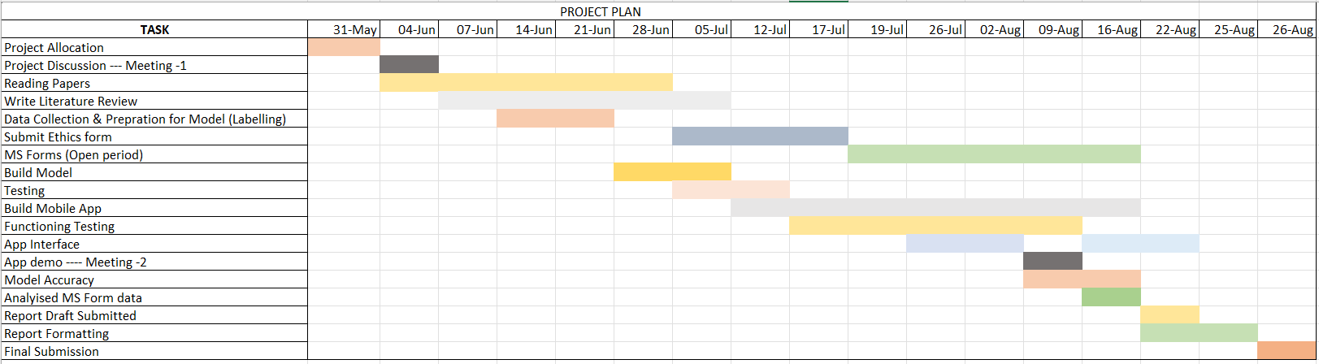
Figure 1: Project Plan

CHAPTER 2: CLIENT REPORT

Acknowledgement

I would like to extend my deepest gratitude to everyone who contributed to the successful completion of this project, Smart Parking Guide: A Solution for Dyslexia-Related Challenges.
First and foremost, I would like to thank my academic supervisor, Dr. Muhammad Irfan, for his invaluable guidance, support, and encouragement throughout the course of this research. His insights and expertise have been instrumental in shaping this project.
I am also immensely grateful to the Strathclyde Business School for providing me with the resources, environment, and unwavering support necessary not only to conduct this research but also to achieve my academic goals and complete my master's degree. The opportunity to work on this project has been an invaluable learning experience, allowing me to contribute to society by addressing the challenges faced by dyslexic individuals in understanding parking signs. I am deeply appreciative of the role the institution has played in my academic journey and in enabling me to tackle this important issue.
Special thanks to the participants who took part in the study and provided feedback that was crucial in refining the mobile application. Their willingness to engage with the project has helped to ensure that the solution developed is both practical and effective.
Lastly, I would like to express my heartfelt appreciation to my family and friends for their continuous support and encouragement throughout this journey. Their belief in me has been a source of strength during the most challenging times.
Thank you all for your contributions to this project and for helping me reach this important milestone in my life, while also contributing to a meaningful cause.

Executive Summary

The Smart Parking Guide is aimed to solve the problems of people with dyslexia who need to decipher complicated parking signs, something which is oftentimes impossible due to the effect of this condition on reading and processing visual information. In the UK, the high percentage of the population having dyslexia results in an incredibly high rate of infractions committed against the stated rules of parking, increasing the stress levels of the affected drivers.
Based on the above considerations, a mobile application was developed using machine-learning technologies, thus providing instant interpretations of parking signs. Development was steered by the insights generated from a deep literature review and user surveys, which established some of the key challenges the targeted persons are facing. The developed application in React Native offers textual guidance; hence, it is more accessible and friendly.
While most of its primary goals were achieved, this project also identified areas for future improvement, specifically the enhancement of the machine learning model's accuracy and integration with other features, such as GPS navigation.
In a nutshell, the Smart Parking Guide project offers a pragmatic solution to a rather ubiquitous problem and puts forward autonomy for the dyslexic driver that will contribute toward developing more inclusive urban environments. The research findings provide evidence that technological interventions have the potential for addressing explicit challenges that people with learning disabilities face in everyday situations.

2.1 Introduction

Specifically, the Smart Parking Guide project deals with some challenges that persons with dyslexia face in cities, focusing particularly on the interpretation of parking signs. It is known that a large part of the population suffers from dyslexia, mostly in reading and spelling, while some studies have shown an impairment in the processing of visual information. The difficulties posed by this condition are not limited to academics; they also extend to practical activities like driving. In particular, the complexity and variability of parking sign information are especially problematic for the dyslexic driver and can result in parking violations, increased anxiety, and decreased independence.
Whereas traditional assistive technologies have focused much on educational support for people with dyslexia, leaving real-world challenges largely unexplored, the Smart Parking Guide project sought to close this gap by using advanced machine learning and mobile technology to provide real-time assistance to a dyslexic driver. It starts off with a detailed literature review about the prevalence of the condition in the UK, its impact on the day-to-day life, and what exactly are the limitations of existing technologies. This review made it very clear that those with dyslexia have problems processing visual information, specially under pressure situations like parking, where the misinterpretation of lines could mean legal and financial implications.
After the literature review, some user research that involves questionnaires to draw first-hand impressions of the problems faced by dyslexic drivers. Then, using these insights, a machine learning model recognizable and interpretable for different parking signs is created. This model was implemented within a developed mobile application. For cross-platform compatibility and accessibility, React Native was used for it. It can be used to provide translations of parking signs, accommodating all sorts of user preferences and needs.
This project will allow dyslexic drivers to feel more confident and self-sufficient when driving because it eliminates much of the stress and complication associated with urban parking. It is hoped that this result will be one element of a greater trend toward inclusiveness and accessibility within an urban environment for easier and more confident navigation by all people, regardless of cognitive differences.

2.2 Literature Review

Dyslexia is a neurodevelopmental disorder that forms the inability of an individual to read, write, and interpret any kind of visual information properly [28]. The literature review illustrates the difficulty a dyslexic individual in the UK faces when trying to interpret parking signs and examines the possibility of a mobile app with image recognition technology to help solve the problems.

2.2.1 Dyslexia in the UK: Its Prevalence and Impact
In the United Kingdom, dyslexia is highly prevalent. The most recent estimates indicate that 10-15% of the population in the UK suffers from some degree of dyslexia. According to the British Dyslexia Association (BDA), dyslexia is a learning difficulty that is characterized by problems usually in acquiring literacy in areas of accurate and fluent word reading and spelling [28].
The consequences of dyslexia, however, are not just limited within the boundaries of educational institutions but spill over into daily life in the UK. Certainly, as a recent University of York investigation discovered, dyslexic adults in the UK experienced significantly higher stress and anxiety levels about daily reading activities and visual information processing, including getting around public spaces and understanding signage [4].

2.2.2 Navigating the UK's Urban Landscape with Dyslexia
The complex UK urban layouts, together with variable signage systems, make this challenge uniquely difficult for anyone with dyslexia. The results of research carried out at the University of Manchester indicated that UK dyslexic adults found navigating around an urban environment much more challenging than non-dyslexic adults. This difficulty is particularly acute in the interpretation of parking signs, which can vary significantly between local authorities.
One study by the Department for Transport found that a whopping 68% of those who reported having dyslexia found parking restriction signs hard to understand, in contrast to 23% of those who did not. This discrepancy underlines the need for poignant solutions that might help the dyslexic negotiate the UK's urban spaces.

2.2.3 UK Parking Regulations and Dyslexia
The UK's parking regulations are particularly complex, and they vary by local authorities. According to a study conducted by the RAC Foundation, a UK charity that supports careful drivers, there are over 30 different types of parking restrictions in operation across the UK [17]. This in itself is one big difficulty for someone with dyslexia because they find it very difficult to process and understand quickly the various different types of visual information on parking signs.
Research done at the University of Leeds concluded that the average time taken by dyslexic people to interpret parking signs was 40% greater than it was for the non-dyslexic people [2]. This will highly increase the level of stress and likely lead to parking violations, thus highly needing the assistance for assistive technologies tailored for the parking scenarios in the UK.

2.2.4 Assistive Technologies for Dyslexic Individuals in the UK
The UK has been at the forefront of many assistive technologies developments that are customized to be dyslexic specific. However, despite a review that was far-reaching undertaken by the British Assistive Technology Association, the revelations were that, including all the technologies and solutions for reading and writing, there remains a wide lacking of support in effective practical visual interpretation [1].
Another promising development is by researchers at the University of Oxford, who are exploring how AR could be used in support of interpreting complex visual information by people with dyslexia [31]. Their work has potential for scaling up and developing into a real-time assistive technology, not only for parking signs but also for other challenges of urban navigation.

2.2.5 Image Recognition Technologies and UK Urban Environments
Recent advances in image-based pattern recognition now pave the way to extend this help. Researchers at Imperial College London explored how machine learning algorithms could be used to interpret complex urban wayfinding signage [15]. Such solutions would have specific benefits where the interpretation of the wide variety of parking signs found in UK towns and cities is concerned.
The UK government initiative in artificial intelligence and data-driven innovation has again fueled research in this area. One such project of a mobile application funded by Innovate UK, already in their portfolio, focuses on image recognition for interpreting roadside signs and providing audio descriptions [5]. While not directly related to parking signs or dyslexia, the project becomes representative of a trend toward trying to make urban navigation a better experience using technology to assist.

2.2.6 Smart Cities and Accessibility in the UK
There has been the rising consideration of building smart cities in the UK. Different cities in the UK have been adopting various technologies that aim at making the urban living environment better. However, according to this report by the UK parliament's All-Party Parliamentary Group on Smart Cities, the moving efforts fail to consider neurodiverse needs, such as those for people with dyslexia [14].
As a result, the city of Bristol has taken a step towards including this feature in its smart city projects by launching a pilot scheme, for instance, in a mobile application that provides simpler, dyslexia-friendly interpretations by visually representing, for example, parking regulations [29]. Should this scheme prove successful, it is likely to be adopted by other municipalities in the UK.

2.2.7 Legislation and Help in the UK for People with Dyslexia
In this context, the legal framework in the UK helps considerably in supporting the needs of persons with dyslexia: the provisions of the Equality Act of 2010 require suitable adjustments to be made for meeting the needs of persons with disabilities, including dyslexia, in various contexts [18]. Special reference is made to the possible implications of this Act on the development of assistive technologies and the design of urban spaces, including parking systems.
In a driving context, the DVSA provides this for people with dyslexia taking their theory test with extra time, screen reader accessibility, or question reading at the beginning or the time of sitting the test [12], however, this does not offer practical assistance in translating parking sign information.

2.2.8 UK Research on Cognitive Processing and Visual Information
UK cognitive psychologists-based research has led to significant understanding of how dyslexic people process visual information. Research out of the University of Cambridge shows that dyslexic adults find rapid visual processing difficult and this is used in the processing of the dynamic material signage around the built environment.
Expanding on this, Queen Mary University of London has also recently explored how what they term simplified illustration can help those with dyslexia process complex visual information [17]. The conclusions drawn from their research appear to be that designing the parking signs with dyslexic principles in mind would lead to a significantly greater level of understanding.

2.2.9 Technology Adoption for Dyslexic Adults in the UK
Big Data could be used to understand this adoption pattern in dyslexic adults in the UK. A survey conducted during a Dyslexia Action workshop found that 78% of the dyslexic adults in the UK use smartphone applications for helping in everyday tasks [22]. This degree of usage of technology is quite high, and it suggests that the base among the general population for the development of a mobile application for interpreting parking signs might be reasonably large.
But in the same survey, it was also found that most of the available apps are not suited to the peculiar needs of the dyslexic, as 65% of the respondents are having a problem using mainstream navigation apps [22]. This clearly flags the necessity for user-driven designs while developing assistive technologies for such individuals.

2.2.10 Economic Impact of Parking Challenges among Dyslexic people
The economic implications of the parking problems are significant to all the people with dyslexia. A report by the company Centre for Economics and Business Research estimated that an average dyslexic driver in the UK, on average, annually contributed more than £150 to the local council in parking fines compared to non-dyslexic peers [19]. The problem is at its core a product of misinterpretation of parking signs and restrictions.
Also in the same survey, the output revealed that dyslexic individuals would tend to stay away from particular city areas, involving intricate parking regulations, and this consequently affects their work prospects, as well as social pursuits [19]. These outputs will then highlight the greater social impact and potential advantages that may be attained if an effectively working solution can be crafted.

2.2.11 User-Centered Design for Dyslexic People in the UK
User-centered design remains a critical vital goal in the development of technologies to aid people with dyslexia. While researchers at the University of Dundee have pioneered approaches to include dyslexic people in the design of digital tools, their work again emphasized the need for this process to be iterative; with testing and refinement based on user feedback, especially for apps designed for real-world use [13].
University of Southampton project even went one step further and involved dyslexic people in the development of a university wayfinding app [32]. The output from the project resulted in a number of features that can also be applied in the parking signage interpretation app, such as randomizable colour schemes and simplified map layouts.

2.2.12 Potential Integration with Existing UK Parking Systems
Integration opportunities and integration problems of a parking sign interpretation application with already existing parking systems in UK cities are numerous. Many cities in the UK have been implementing smart parking systems, such as Westminster, London, where parking availability is monitored in real time using sensors [6].
A research study by the University of Exeter examined the effectiveness of building accessibility functionalities into such smart parking solutions [30]. Their system proposed that a synthesis of real-time parking data and sign interpretation tool could go to a considerable extent in addressing the needs of dyslexic UK road users

Gap Analysis
This literature review has underlined that dyslexic individuals are feeling many challenges in interpreting car parking signs in the UK and navigating urban environments. It also points out the need for doing new ways of solutions using new technologies, such as image recognition and augmented reality, to get in-real-time aid.
One such solution, in the current scenario in the context of the UK, is the development of a mobile application through the use of the image recognition technology associated with interpreting parking signs. The following application could expand on the state of the art of assistive technologies for smart parking systems and the support of dyslexic drivers to bring a greater improvement to the user experience in the UK's cities, thus reducing stress and avoidance possibly not in legal infringement.

2.3 Methodology

This section provides a detailed overview of the processes and techniques used to achieve the objectives of the "Smart Parking Guide" project. It encompasses two primary areas: data analysis and mobile application development.
The data analysis section outlines the collection and examination of survey data to identify their challenges with parking signs. This includes demographic analysis, driving experience, and feedback on the proposed solution.
The mobile application development section describes the technical steps involved in building the app, including model training, integration, and the design of user interfaces to ensure the tool effectively assists users in real-time parking scenarios.

2.3.1 Data Analysis
The survey garnered a total of 72 responses [MS Form Responses]. To maximize participation, I distributed the Microsoft survey (MS Form) link across various social media groups and networks, encouraging my friends to further share it within their communities. Additionally, I proactively reached out to organizations that specialize in supporting individuals with dyslexia or those requiring specific adjustments for their driving theory tests. These organizations were instrumental in reaching a broader and more relevant audience, ensuring that the survey included insights from individuals who directly experience the challenges under investigation.

Demographic Insights
The demographic insights derived from the survey provides a comprehensive overview of the respondents' characteristics, focusing on three key areas: age distribution, gender composition, and education levels. These insights are crucial for understanding the profile of our sample population and contextualizing the subsequent findings.
By analyzing these demographic factors, we can better interpret the survey results and tailor the development of our smart parking guide to meet the needs of its potential users. The following sections delve into each of these demographic aspects, offering a detailed picture of who our respondents are and how their characteristics might influence their perspectives on parking challenges and technological solutions.

1. Age and Gender Distribution:
Among the respondents, a significant portion, 41.4%, fell within the 18-25 age group (Figure 2), highlighting the engagement of younger individuals in this research. This age demographic is often more accustomed to using digital tools, which could explain their higher representation.
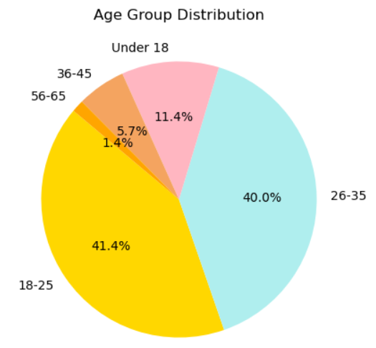
Figure 2: Age Group Distribution
In terms of gender distribution, 64.29% of the participants identified as male, making them the predominant gender in the survey (Figure 3).
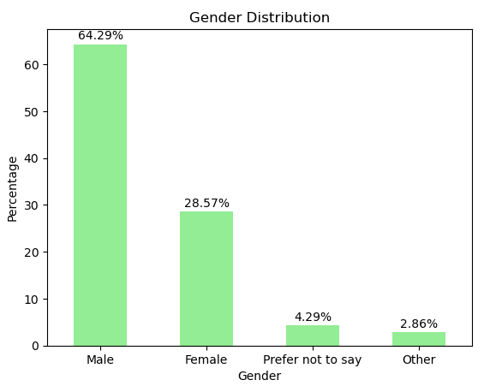
Figure 3: Gender Distribution
This gender skew may reflect the broader demographics of those who are actively driving or interested in parking solutions, though it also underscores the importance of considering gender perspectives in the development of assistive technologies for parking.

2. Education Level:
The educational background of the survey participants revealed that nearly half, 48.57%, of the respondents held a Bachelor's degree, making this the most common level of education among those surveyed (Figure 4). This prevalence of Bachelor's degree holders suggests that the survey reached a well-educated demographic, potentially reflecting the characteristics of individuals who are more likely to engage with new technological solutions, such as the proposed smart parking guide.
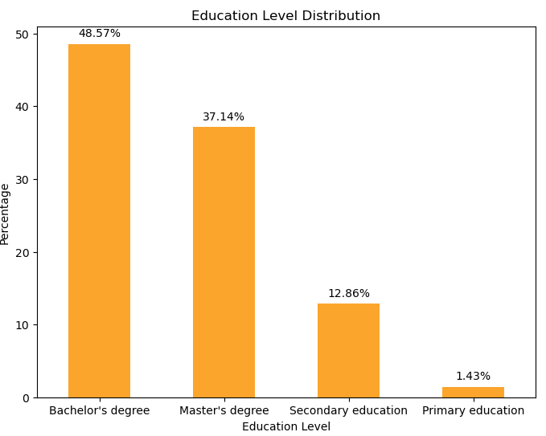
Figure 4: Education Level Distribution
Additionally, respondents with a Master’s degree formed the second largest group, further emphasizing the survey’s reach among those with advanced educational backgrounds. This educational profile indicates that the participants likely possess a strong understanding of the challenges and potential benefits of using image recognition technology for interpreting parking signs, making their feedback particularly valuable for the development of the application.

Driving Experience

1.Driving Prevalence:
The survey results highlight a significant prevalence of driving among participants, with an overwhelming 61.43% indicating that they drive regularly (Figure 5).
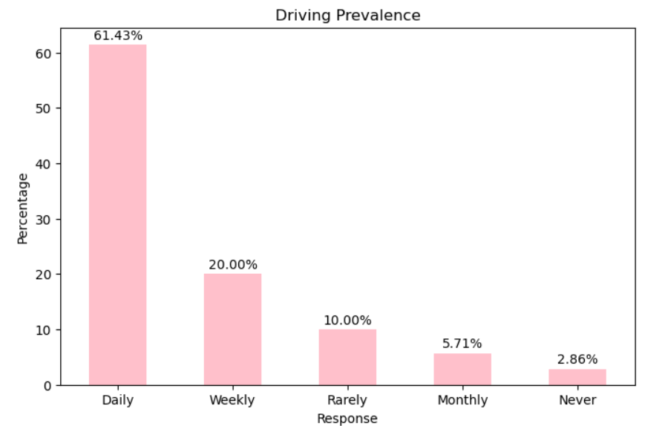
Figure 5: Driving Prevalence Distribution
Additionally, 87.1% of the respondents possess a valid driving license, underscoring the relevance of this study to a population actively engaged in driving (Figure 6). This high percentage of drivers among the participants suggests that the findings of this survey are particularly pertinent to the target audience of the proposed smart parking guide, as these individuals are regularly encountering parking signs and would benefit from improved interpretive assistance.
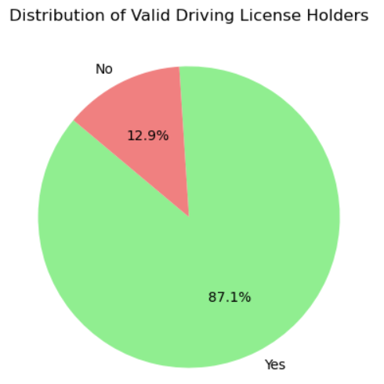
Figure 6: Distribution of Valid Driving License Holders

2.Driving Experience:
The survey revealed that around 30 respondents have been driving for 3-5 years (Figure 7), making this the most common experience range among participants. This group likely represents a cohort that has developed a solid understanding of driving and navigating road systems but may still encounter challenges with complex parking signs.
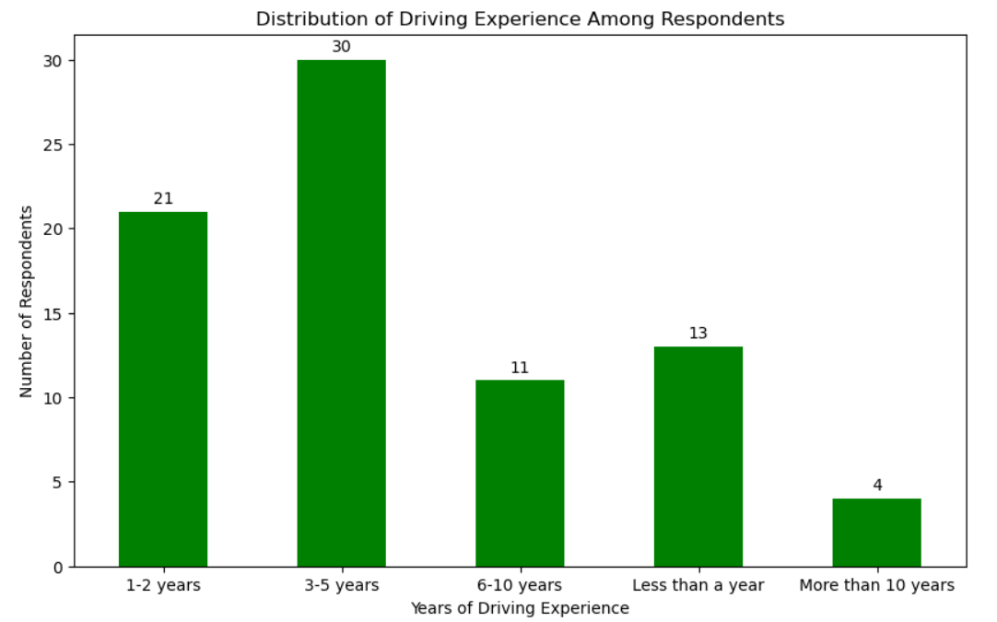
Figure 7: Distribution of Driving Experience
Among the respondents, 18.6% indicated that they had requested reasonable adjustments related to dyslexia during their theory driving test. This indicates that a minority of individuals with dyslexia are actively seeking out the support available to them, which may reflect varying levels of awareness or perceived need for these accommodations.
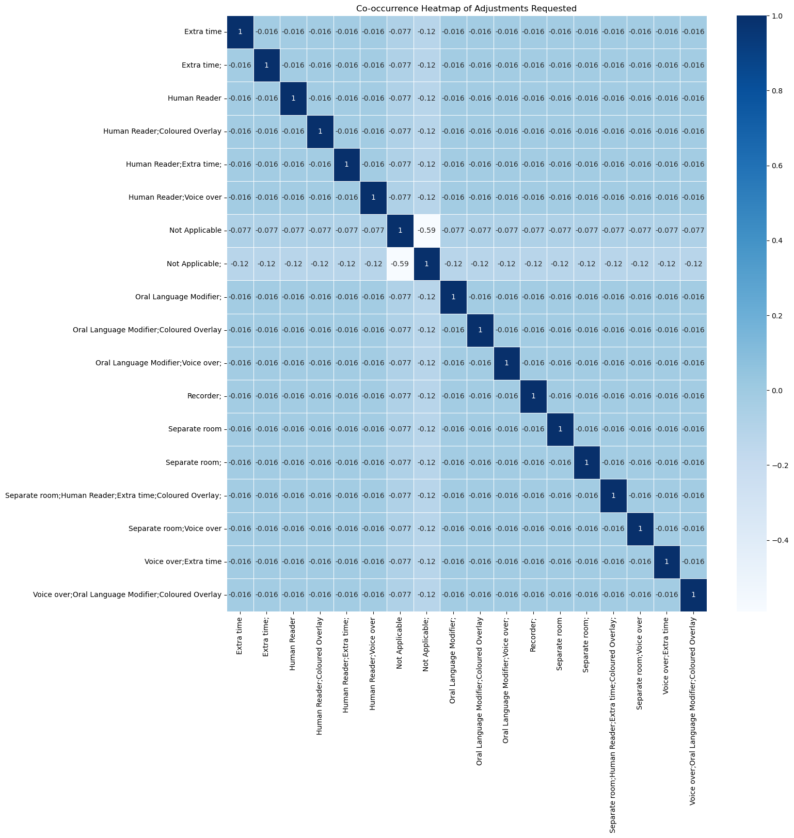
Figure 8: Corelation Heatmap of Adjustments requested
Figure 8, the heatmap provides a detailed visualization of the co-occurrence of different types of reasonable adjustments requested by participants with dyslexia during their driving tests. The most commonly requested services include the provision of a separate room and extra time, as indicated by the prominent darker cells along the diagonal. These adjustments are particularly designed to create an environment that minimizes external distractions and allows individuals to process the test information at a pace more suited to their needs. The separate room offers a quiet space, which can be crucial for reducing the anxiety and pressure associated with taking the test in a standard setting. Extra time, on the other hand, alleviates the time constraints that might otherwise exacerbate the challenges associated with dyslexia, ensuring that the test assesses the participant's driving knowledge and skills rather than their ability to read quickly.
Additionally, the heatmap reveals that other commonly requested adjustments include the use of a voice-over for the test instructions and the assistance of a human reader. These services are particularly important for participants who struggle with reading and comprehension. The voice-over feature ensures that participants can hear the instructions clearly, reducing the reliance on reading, which can be a significant hurdle for those with dyslexia. Similarly, the human reader provides direct assistance by reading the test questions aloud, ensuring that the participant fully understands the questions without being hindered by reading difficulties. These accommodations collectively aim to level the playing field, ensuring that the driving test measures the participants' true driving abilities rather than their literacy skills. The correlations seen in the heatmap suggest that these adjustments are often requested together, highlighting a comprehensive approach to addressing the specific needs of individuals with dyslexia during the testing process.

Challenges with Parking Signs
The survey responses show that for most, on-street parking signs are a somewhat challenging aspect to comprehend. In fact, 42 of respondents replied that they sometimes have problems understanding what an on-street parking sign is trying to communicate, underlining the problems that may arise for the drivers, in particular those suffering from dyslexia. Not being able to clearly understand parking signs brings confusion and probable mistakes in following regulations related to parking, which may be fined or even have other legal penalties.
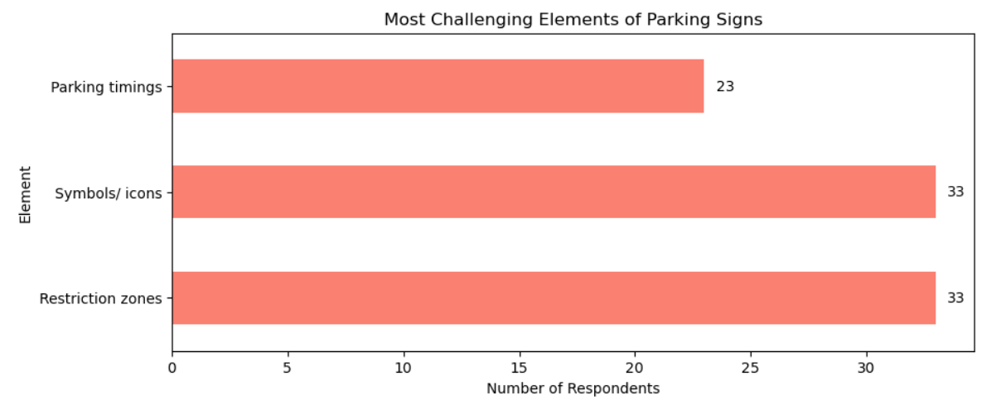
Figure 9: Most Challenging Elements of Parking Signs
Restriction zones and symbols/icons are the most-quoted elements about parking signs as posing difficulty, shown in Figure 9. Normally, these are visually complicated pieces of information which require fast and accurate perception, thus they pose a challenge to those with dyslexia who may have problems in processing and decoding information through sight. These challenges are repeatedly stated and thus point to a need for appropriate solutions in order to give clear and accessible interpretations of these confusing elements, therefore reducing the risk of errors and generally making the parking experience easier for dyslexic drivers.

Feedback on Proposed System:
The feedback on the proposed smart parking guide system, which uses image recognition to interpret parking signs, was overwhelmingly positive. A significant 68.1% of respondents indicated that they would likely use a mobile app designed to help drivers (Figure 10), particularly those with dyslexia, better understand parking signs. This strong interest reflects the demand for such a solution and underscores its potential impact on improving daily driving experiences.
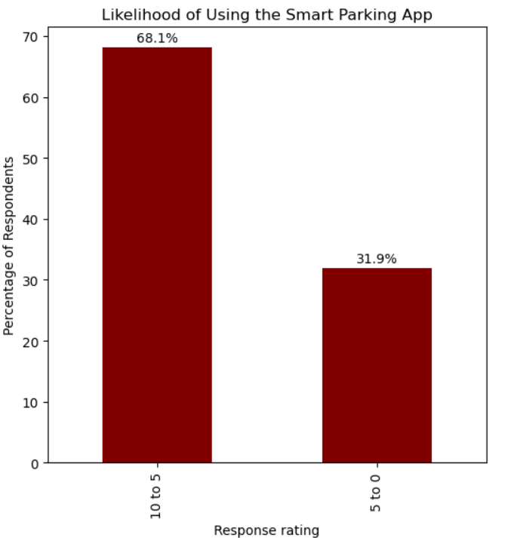
Figure 10: Likelihood of Using Smart Parking App
When it comes to the preferred features of the app, text-based interpretation emerged as the most favoured method of delivering information, with many respondents finding this approach most accessible and straightforward (Figure 11). Close behind was audio-based interpretation, which would allow users to receive spoken instructions or explanations, catering to those who might find listening easier than reading, especially in a driving context. The preference for these features highlights the importance of providing multiple modes of interpretation to accommodate different user needs and preferences.
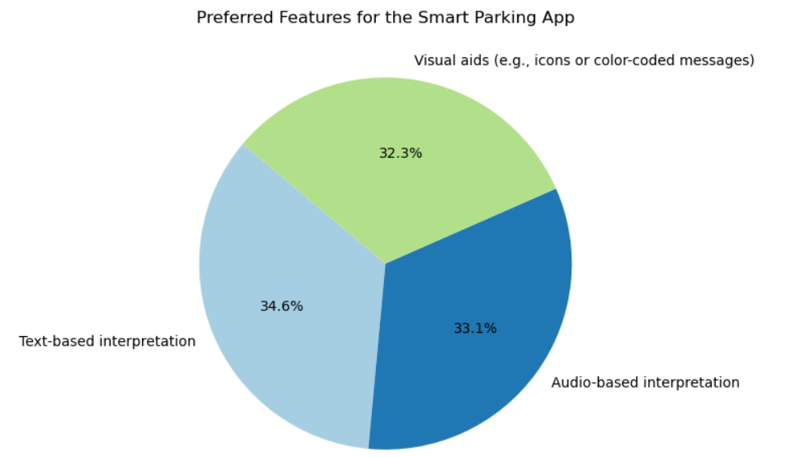
Figure 11: Preferred Features for App
Moreover, the importance of real-time updates on parking restrictions was strongly emphasized by the majority of respondents (Figure 12). This feature is critical because parking rules often change based on time of day or special events, and real-time information would help drivers avoid costly mistakes. The emphasis on real-time updates suggests that users are looking for a dynamic, reliable tool that can adapt to their immediate surroundings.
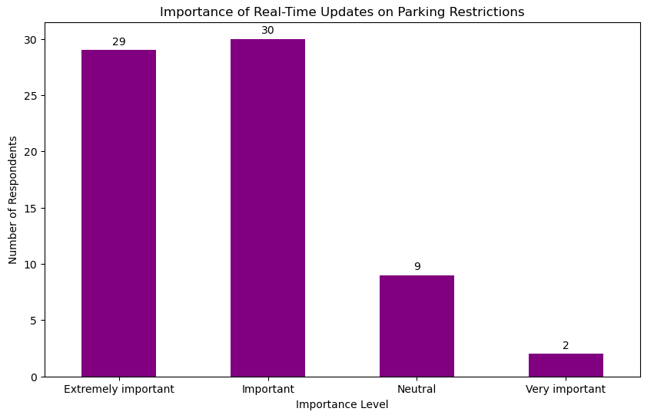
Figure 12: Importance of real-time updates on parking restrictions
In regard to additional functionality, it was GPS navigation to available parking spots (Figure 13), thereby making the application part of their navigation experience and turning it into an all-in-one tool in relation to parking problems. Moreover, many respondents would appreciate being warned about the expiration of their parking spot. This would ensure that no ticket or fine is issued due to expiration of the parking period because users are warned when their time is running out. These preferences suggest that the user wants a holistic solution to help in interpreting parking signs but assist in practicalities of finding and managing parking.
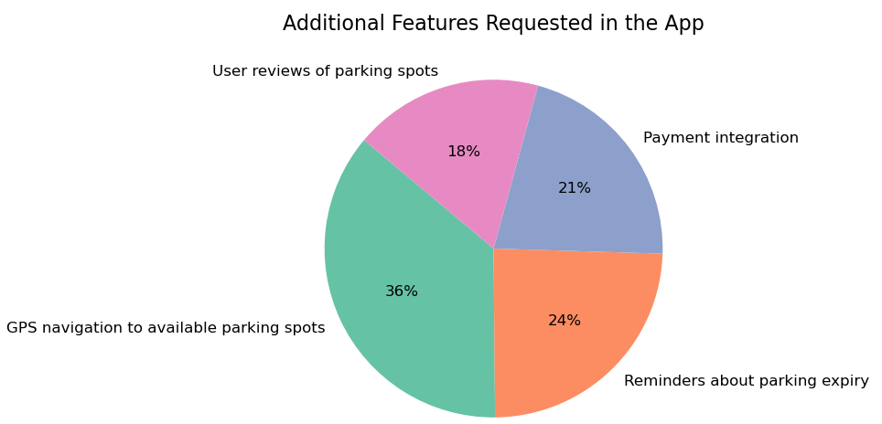
Figure 13: Additional Functionalities in App

2.3.2 Mobile Application Development
The mobile application development phase focuses on integrating the deep learning model into a user-friendly app that assists users in interpreting parking signs. Leveraging React Native [20] for cross-platform compatibility and Expo [11] for managing device capabilities, this phase aims to create a seamless interface where users can capture images of parking signs and receive real-time feedback. By combining advanced machine learning with intuitive design, the app will enhance the accessibility and understanding of parking regulations, particularly for those who find complex signage challenging to interpret.

2.3.2.1 Model building
The most critical steps, however, was to build a model that could classify parking signs correctly and be a reliable, efficient deep-learning model. This section details every step of building the model, pointing out the reasons for the choices made and what makes each one integral to its effectiveness in real life.

2.3.2.1.1 Data Collection
Data collection was first and most crucial step. The images were primarily extracted from the " know-your-traffic-signs-dft" file [10] provided with the project information. To expand the dataset and enhance the model's ability to generalize, additional images were sourced from the internet.

2.3.2.1.2 Data Preparation
The dataset was prepared with 48images which belonged to 31 classes (Figure 14).
The ImageDataGenerator class in Keras was used for real-time data augmentation [25]. These transformations helped simulate a variety of real-world conditions, ensuring that the model could handle diverse scenarios.
These transformations included:
• Rescaling: This involves normalizing the pixel values by scaling them down by a factor of 255, converting the range from [0, 255] to [0, 1]. Normalization is a critical step because it ensures that the data is on a consistent scale, which in turn helps the model converge faster during training.
• Rotation: The images were randomly rotated within a range of 20 degrees. This augmentation helps the model learn to recognize objects regardless of their orientation, which is crucial in real-world scenarios where the orientation of objects may vary.
• Shifting: Horizontal and vertical shifts were applied, moving the images within 20% of their width or height. This simulates scenarios where objects are slightly off-center in the frame, helping the model become more robust in recognizing objects that are not perfectly aligned.
• Shearing: A shear transformation was applied to slant the images, mimicking the effect of tilting the camera angle. This type of augmentation helps the model generalize better by exposing it to different perspectives of the same object.
• Zooming: Random zooming in and out by up to 20% was used to simulate different object scales, training the model to recognize objects at varying distances.
• Horizontal Flipping: Random horizontal flips were applied, which is particularly useful when the object’s orientation does not change its classification. For instance, flipping a parking sign horizontally does not alter its meaning, so the model should correctly classify it regardless of the flip.
• Fill Mode: When these transformations caused parts of the image to move out of the frame, new pixels were filled using the nearest pixel values, preserving the integrity of the image.
Following data augmentation, the images were loaded from a directory using the flow_from_directory method (Figure 14). This method automatically organizes images into batches and assigns labels based on the subdirectory structure. The images were resized to 150x150 pixels, which is the input size required by the InceptionV3 model. The labels were one-hot encoded, converting them into binary vectors suitable for categorical classification.
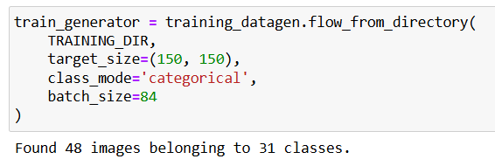
Figure 14: Dataset

2.3.2.1.3 Importing Required Libraries
The first step in making the deep learning model was to import some of the most important libraries needed to build up, train, and test the model. Core libraries used in this task were TensorFlow and Keras. In general, TensorFlow acts as the backbone that provides the computational framework, while Keras is more intuitive and user-friendly with a well-designed API to help build neural networks more easily.
Moreover, Matplotlib was utilized for data visualization, plotting training progress, or simply when sample images from the dataset needed to be displayed. The ImageDataGenerator from Keras is particularly significant as it facilitates real-time data augmentation and efficient data loading, which are essential for enhancing model generalization and preventing overfitting.
Moreover, to ensure the training process is effectively monitored, callbacks like EarlyStopping and ModelCheckpoint were used [27]. These callbacks help in halting the training when no further improvements are detected and in saving the best-performing model based on validation performance.

2.3.2.1.4 Setting Up the Pre-Trained Model
In the model-building process, InceptionV3, a well-known pre-trained convolutional neural network, was utilized due to its strong feature extraction capabilities [26]. InceptionV3 was loaded without its top layers, which typically handle classification tasks, allowing the model to serve primarily as a feature extractor in this application.
The pre-trained weights for this model, originally trained on the ImageNet dataset, were loaded to leverage the extensive knowledge the model already possesses about a wide variety of image features. To ensure that the feature extraction capabilities of the pre-trained model are preserved during the training of the new layers, all layers of the InceptionV3 model were frozen. This means that their weights were not updated during the training process, allowing the new layers added on top to learn specific patterns related to the new dataset without altering the robust features already captured by InceptionV3.

2.3.2.1.5 Customizing the Model
After setting up a pre-trained model, what was needed thereafter was to fine-tune it for the task at hand: categorizing images into one of 31 possible categories.
The customization began by selecting the output from the mixed7 layer, an intermediate layer in the InceptionV3 model, as the input for the new custom layers [21]. This choice was strategic, as the mixed7 layer provides a good balance between extracting high-level features and maintaining computational efficiency. The output from this layer was then passed through a flatten layer, which converted the 3D feature maps into a 1D vector, making it suitable for input into the fully connected layers that followed. Also, a dense layer with 1,024 units and ReLU activation was added to introduce non-linearity into the model to capture complicated patterns and relationships within the data.
A dropout layer with a rate of 0.2 was further added to improve generalizability and avoid overfitting. This layer will randomly set 20% of the input units to zero during every update cycle, breaking the model's dependence on some neuron characteristics.
The final layer used softmax activation to classify the input images into one of 31 categories, which is ideal for multi-class classification tasks.

2.3.2.1.6 Compiling the Model
Once the model architecture was defined, it needed to be compiled with appropriate settings to prepare it for training. Categorical crossentropy was chosen as the loss function, which is standard for multi-class classification problems. This loss function measures the performance of the model by comparing the predicted probabilities to the actual class labels, guiding the optimization process.
The RMSprop optimizer was selected with a small learning rate to fine-tune the model [21]. The choice of a small learning rate is critical in this context because it allows the new layers to learn effectively without drastically altering the pre-trained weights from InceptionV3. Accuracy was chosen as the metric to monitor during training and validation, providing a clear measure of how well the model is performing in classifying the images correctly.

2.3.2.1.7 Training the Model
After data preparation and model compilation, the first step in the training has begun with the augmented data from ImageDataGenerator. A range of strategies has been applied during this time to ensure the model is well trained and doesn't face general issues, like when a model may perform well on training and validation data but not on unseen data.
It was done by utilizing the EarlyStopping callback function, which monitors validation loss and stops training automatically if it does not improve over a given number of epochs. This helped stop the overfitting of training data and divergence of the model to keep it general for unseen data.
Another important callback used was ModelCheckpoint, which saved the model whenever there was an improvement in the validation loss. The method described enables saving the best version of the model during the training process and thus mitigating the risk of saving a model that may have suffered from overfitting or failed in the last epochs.
Furthermore, a specific callback function was implemented to halt the training process once the model achieve minimum of 94% accuracy on the training dataset. This step was critical in maintaining a balance between achieving high accuracy and preventing overfitting. As shown in the provided training log, the model reached 94% accuracy at epoch 91(shown in Figure 15), and shortly after, it achieved 95.83% accuracy, at which point the training was automatically stopped. This precise stopping mechanism helped to lock in the model's performance at its optimal point, ensuring that it was neither overtrained nor undertrained, thus preserving its generalization ability for real-world application scenarios.
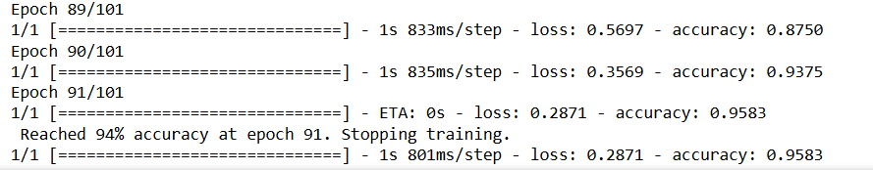
Figure 15: Training epoch results

2.3.2.1.8 Saving the Model
Upon completion of the training process, the model was saved as an .h5 file, which includes the model architecture, trained weights, and the optimizer state. This file format is compatible with various deployment environments and can be easily loaded for inference. The saved model is particularly valuable for deployment in a mobile application, where it can be integrated to recognize and interpret parking signs. This made the model a practical tool for real-world applications, especially in assisting drivers with understanding parking regulations.

Significance for Model Training
This entire process, from data preparation to model training and saving, it forms an integral process in effectiveness and reliability while using the model in real-world scenarios. Thus, this combination of data augmentation and efficient batch processing ensures that enough diversity of images is present for the model to learn even with a small dataset size. By augmenting the data in real-time, the model is less likely to overfit to the limited examples available and more likely to generalize well to new, unseen data. This is particularly important in applications like a mobile app for interpreting parking signs, where the model needs to handle diverse and dynamic conditions effectively. Overall, this approach ensures that the model achieves high accuracy and reliability, making it a robust solution for practical use cases.

2.3.2.2 App Development
In this project phase, we work on the development of a mobile application that is supposed to help users decipher parking signs. It will use a previously developed and saved machine learning model in .h5 format. This model, trained to recognize and classify different parking signs, is used in this app to allow real-time feedback to users via images taken with their mobile device's camera.
Basically, the idea is to make the parking rules more accessible and understandable to anyone, especially those confused by the likes of these complex signs. After training the model, we will integrate it with the app; this now enables the app to analyze pictures of parking signs, giving the user information about whether he is allowed to park in the indicated parking space, and if necessary, display what kind of permit might be needed.
The app is built using Expo, a platform for building apps with React Native that simplifies the development process by providing tools and services to handle various device capabilities, including camera functionality and file system access.
In this phase of the project, we will set up navigation in the application, design user interfaces, integrate a TensorFlow model, and capture/develop image processing. Upon completion of this phase, we will have a fully functional mobile application capable of guiding users through the complexities of parking regulations in real-time.

2.3.2.2.1 Model Conversion
To integrate the deep learning model into the mobile application efficiently, the original .h5 model file was converted into a format compatible with TensorFlow.js. This conversion process involved using the TensorFlow.js converter, which transformed the .h5 file into a JSON format along with associated weight files. Specifically, the model's architecture was stored in a single JSON file, while the model's weights were split into 5 shard.bin files (Figure 16).
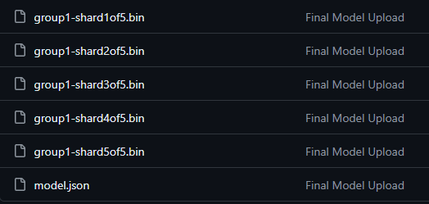
Figure 16: Model Conversion
These files—the JSON model file and the five weight shard files—were then hosted on GitHub. In the application, when the model is needed, the app dynamically loads the JSON file directly from GitHub, along with the weight files, to perform the necessary computations.
The primary reason for this approach is to avoid making the application excessively heavy. By hosting the model and its weights externally on GitHub, we significantly reduce the size of the app package. This approach ensures that the app remains lightweight and performs efficiently, particularly in resource-constrained environments like mobile devices. Additionally, it allows for easier updates to the model, as changes can be made on GitHub without requiring users to download a new version of the app.

The app is a combination of well-structured navigation, user-friendly interfaces, and powerful machine learning capabilities.
Below, we’ll walk through the working of the application using the three key files:
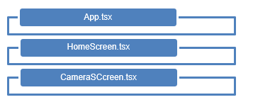
Figure 17: 3 Key files

2.3.2.2.2 Setting Up the Navigation Structure (App.tsx)
The App.tsx file is the foundational entry point of the mobile application, responsible for setting up and managing the navigation structure that dictates how users move between different screens.
React Navigation is employed to facilitate smooth transitions between the two primary screens: the HomeScreen and the CameraScreen. The application utilizes a stack navigator, which allows users to navigate forward and backward between screens, similar to flipping through a stack of cards.

i. Defining the Navigation Flow
In App.tsx, the navigation flow is defined using the stack navigator. The two main screens that form the core of the app’s functionality are the HomeScreen and the CameraScreen.
The HomeScreen serves as the initial screen that users encounter upon launching the app, while the CameraScreen is where users can capture images of parking signs for analysis. The stack navigator setup ensures that users can move seamlessly between these screens, enhancing the overall user experience.

ii. Navigation Container and Stack Navigator
The navigation structure is encapsulated within the NavigationContainer, which acts as the root component that manages the app’s navigation state. Inside this container, the Stack.Navigator is defined, specifying the available screens. The HomeScreen, labelled as 'Smart Parking Guide,' is the default screen that loads when the app starts. Users can then navigate to the CameraScreen when they are ready to capture a parking sign image. This clear and intuitive navigation setup ensures that users can easily access the app's functionalities without unnecessary complexity.

2.3.2.2.3 Home Screen Interface and User Interaction (HomeScreen.tsx)
The HomeScreen.tsx file serves as the main interface, providing users with a welcoming and user-friendly entry point to the app. This screen offers users two primary options: to read instructions or to start using the camera. The design is visually engaging, with a background image and two prominent buttons that guide the user’s next steps.

i. Home Screen
Upon launching the app, users are greeted with the HomeScreen, which is designed to be both functional and visually appealing. It has two significant buttons: "Read Instructions" and "Get Started." Tapping on "Read Instructions" shows a modal walking a user through how to use the app—so they know precisely what to do next. This modal overlay persists atop the current screen so that while reading the instructions, the user won't lose their place in the app. The "Get Started" button navigates a user to CameraScreen and serves for starting the capturing of images of parking signs.
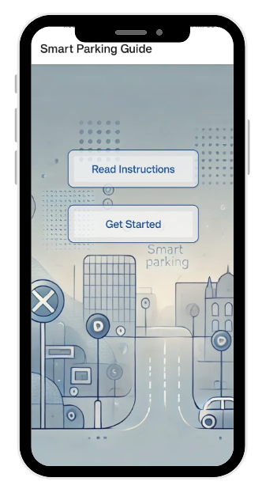
Figure 18: Home Screen

ii. Instruction Screen
The instruction modal provides the user with helpful guidance, particularly the first-time user. In explaining how to effectively use the app, it states that the machine learning model should load and how to take a picture of a parking sign, and what happens next when an image is taken. This way, it will improve the actual overall experience of using the application by making sure that users clearly understand its functionality prior to being allowed to proceed using the app, hence reducing errors.
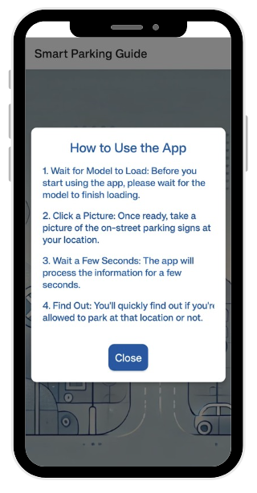
Figure 19: Instruction Screen

2.3.2.2.4 Capturing and Analyzing Images (CameraScreen.tsx)
The core of the app's functionality is in the CameraScreen.tsx file, where all the magic happens. It provides a screen for capturing pictures of parking signs and getting predictions about the parking regulations based on captured images. All of these—loading a machine learning model, capturing and processing images, making predictions, and displaying results to the user—were errors.

i. Loading the Machine Learning Model
When the CameraScreen is first accessed, the app begins by loading the pre-trained TensorFlow model. This model is fetched from a remote server (GitHub repository) and loaded into the app. The loading process is asynchronous and includes a progress indicator, so users are aware that the app is preparing the necessary tools for analysis. This ensures that the model is ready to analyze the captured images as soon as the user takes a picture.
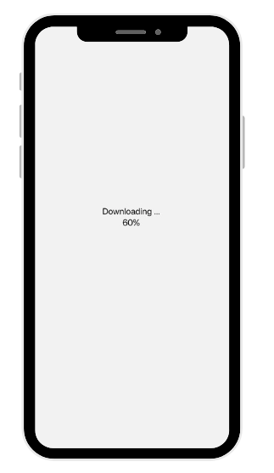
Figure 20: Model Loading Screen

ii. Capturing an Image
After the model has been loaded, the user will click an image of a parking sign with the device's camera. The application asks first for permission to take access to the camera. This step is very important in ensuring the privacy and security of the user [16]. If permission is granted, then the user can take a picture.
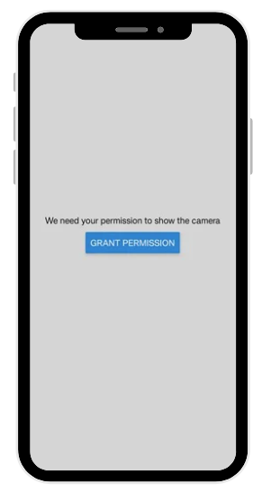
Figure 21: Grant Permission Screen
On pressing the shutter button, the camera captures the image, and it gets processed instantly on the app.
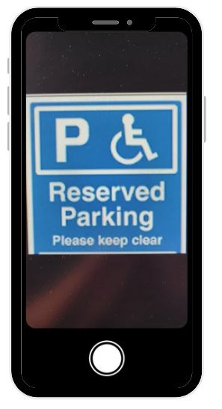
Figure 22: Camera Screen

iii. Processing the Image
After capturing the image, the app processes it to prepare it for analysis. This involves several steps:
- Compression: It is a process where the captured image is compressed to reduce its size, hence easing and increasing the speed in processing it.
- Conversion to Tensor: The compressed image is then converted into a tensor format that the TensorFlow model can deal with. This step shall include resizing the image into appropriate dimensions and normalizing pixel values to ensure consistency in the input data for the model.
- Prediction by Model: The pre-processed image is fed into the TensorFlow model, which in turn predicts the class of the parking sign, such as "No Parking" or "Free Parking." This prediction is taken as the premise of the app's analysis on whether or not parking is allowed.

iv. Analyzing the Prediction
Once the model generates a prediction, the app takes it a step further by determining if parking is allowed based on the current time, day, and any specific permit requirements indicated by the sign.
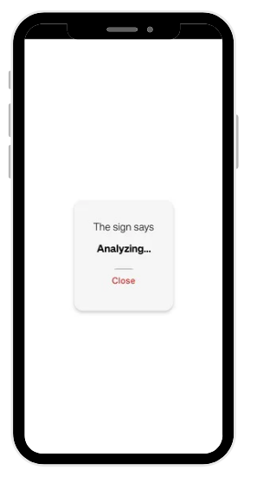
Figure 23: Analyzing Screen

The app checks for:
- Time-Based Restrictions: The app parses the text on the sign to identify any time-specific parking restrictions and checks if the current time falls within those restrictions [2.8.4 Parking Sign Analysis].
- Permit Requirements: It also determines whether any special permit is necessary to park in that location. All these factors are taken into account so as to present the user an accurate and relevant result on their available parking options.

v. Displaying the Results
After the analysis is complete, the application will then show results to the user in a modal. The result modal will contain the captured image and what the app perceives from the parking sign, such as "Yes, you can park here" or "No, you cannot park here." In case a permit is required, it shall be indicated. This kind of real-time feedback helps users decide better on where they may park, reducing the chances of a parking violation.
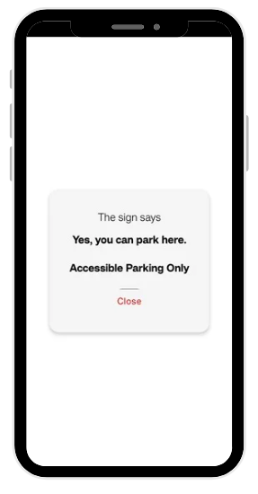
Figure 24: Result Screen

2.4 Results and Findings

The Smart Parking Guide project has yielded several significant findings through the analysis of survey data and the development of a machine learning-based mobile application. The results provide insights into the challenges faced by individuals with dyslexia in interpreting parking signs and demonstrate the potential of assistive technology in addressing these challenges.
Analysis of the survey data revealed that a substantial proportion of respondents (58%) reported difficulties in interpreting on-street parking signs. This finding underscores the prevalence of the problem and validates the need for assistive solutions. Further examination of the data identified restriction zones and symbols/icons as the most challenging elements of parking signs for users. These insights were crucial in informing the design and functionality of the Smart Parking Guide application.
The development of the mobile application using React Native and Expo frameworks proved successful in integrating a machine learning model for parking sign interpretation. The application demonstrates the capability to capture images of parking signs and provide real-time interpretations, bridging the gap between complex visual information and user comprehension. This achievement represents a significant step towards creating accessible solutions for individuals with dyslexia in urban environments.
The machine learning model, which is based on the architecture of InceptionV3 trained on a limited dataset with 48 images across 31 classes, makes out good results in classifying parking signs. Although it was constrained by a small dataset, the implementation of data augmentation techniques has been very important in improving the generalization ability of the model. That approach depicts the potential for such advanced machine learning techniques to leapfrog limitations of data within specialized domains.
The high potential adoption rate, indicated by 68.1% of survey respondents expressing likelihood to use the app, suggests a strong market demand for such assistive technologies. This finding aligns with the project's objective of developing a user-centric solution to address real-world challenges faced by individuals with dyslexia.
Analysis of feature preferences revealed that text-based interpretation emerged as the most preferred method of information delivery among potential users. Additionally, real-time updates on parking restrictions were emphasized as a critical feature by the majority of respondents. These insights provide valuable direction for future iterations of the application, ensuring that development efforts are aligned with user needs and preferences.
The inclusion of accessibility considerations in the app design, such as options for audio-based interpretation, addresses the diverse needs of the target user group. This approach is supported by the survey finding that 18.6% of respondents had requested reasonable adjustments for dyslexia during their driving theory test, indicating a significant need for accessibility features in driving-related contexts.
From a technical perspective, the successful implementation of asynchronous loading of the machine learning model from a remote server and the integration of real-time image processing capabilities demonstrate the feasibility of deploying complex AI models in mobile environments. These achievements lay the groundwork for future enhancements and broader applications of the technology.

2.5 Future Scope of Improvement

While developing a smart parking application, some areas have been identified where future improvements can considerably enhance the functionality of the app, user experience, and its effectiveness overall. The key aspects that could be targeted for improvement are hereby stated below:

2.5.1. Improving Model Accuracy
One of the most critical areas for future improvement is enhancing the accuracy of the machine learning model used to interpret parking signs. While the current model performs adequately, further training with a more extensive and diverse dataset could help it better recognize and classify a wider variety of parking signs under different conditions. This can include training the model on signs showing progressions of the aging process, different lighting conditions, and consequently complex signage. By improving the accuracy, the app will be able to guide about parking more reliably and accurately, which is very important for users who need to rely on the app so that they would not have to pay a fine to any parking authority.

2.5.2. Integrating Permit Holding Information at Registration
Another valuable enhancement would be to incorporate a feature where users can input their permit holding information during the app registration process. This will enable apps to advise on that basis. For instance, if the user has a disability parking permit or resident's parking permit, it should already be factored into the analysis and try to give personalized parking recommendations. This feature is not only desirable for user experience; it also makes sure that the guide given by the app is very relevant and accurate to the needs of every user.

2.5.3. User Interface (UI) Improvements
While the user interface is workable as it is, there are always ways to improve upon the app toward being more intuitive and aesthetically pleasing. Improved UI in the future would most likely include better navigation, clearer visual cues, and modernization of its look and feel for current design trends. Another feature that might become possible at this time is customization of the UI according to taste and need—visually impaired people, for example, or others with special needs. An aptly designed UI will make sure that the app is user-friendly and accessible by the largest number of people.

2.5.4. Including a Zoom Feature
Introducing a zoom feature within the camera functionality would be a significant convenience for users. This way, they can stay within the vehicles and zoom the parking signs placed at a certain distance, bringing the sign close enough to take a clear image without needing to go up to it on their own. This would be especially useful where it is most needed—in busy places or locations where it's hazardous or inconvenient to step out of the car. Adding zoom functionality would make the app more practical and user-friendly, letting it adjust to real-world situations better.

2.5.5. Expanding Sign Recognition Capabilities
As it stands, the application has been developed for a limited set of parking signs. However, it would be very useful if the application covered a greater range of signs, differenced from other regions or more complex signage. This could be attained by increasing the number of classes within the model and training on more images. This could make the app more universally applicable, thus providing valuable assistance to users in a wider variety of parking situations and geographical locations.

2.5.6. Implementing Audio-Based Output
The other key enhancement would be audio-based output. This feature would allow spoken feedback to the user, greatly improving the usability of the app and making it easier to interpret—especially for those who might find it hard to read text from a screen. Audio feedback could specifically be useful for drivers keeping their eyes on the road or those with vision impairments. By adding audio-based guidance, more users would be able to use the app, and it would be easier for all kinds of users to be served according to their needs or limitations.

2.5.7 Improving Image Input Validation
The app needs to be enhanced to detect and handle cases where the captured image is blank or doesn't contain a parking sign. This could involve adding a preliminary check to confirm the presence of a valid sign before conducting a full analysis. Such an improvement would prevent the app from generating inaccurate results based on inappropriate inputs.

2.5.8 Educational Module for Users with Dyslexia
A valuable addition to the app will be an interactive learning feature designed specifically for users with dyslexia. This module could offer lessons and quizzes to help users recognize and interpret various parking signs. By combining immediate parking guidance with educational content, the app could empower users to develop their sign-reading skills. This approach would be particularly beneficial for individuals with dyslexia, enhancing their ability to understand parking signage independently and increasing the overall value of the app.

2.6 Conclusion

The Smart Parking Guide project successfully developed a mobile application to assist dyslexic individuals in interpreting parking signs, addressing a critical challenge in urban mobility. By combining user research, machine learning, and accessibility-focused design, the project produced a tool with significant potential to improve the parking experience for dyslexic drivers. A survey conducted during the project revealed a strong demand for such assistive technology, validating the need for accessibility solutions in urban environments. The integration of a machine learning model into the app showcased the practical application of artificial intelligence in solving real-world accessibility issues, despite limitations in the training dataset.
The machine learning model's development, employing transfer learning and data augmentation, demonstrated the feasibility of automated parking sign interpretation, emphasizing the importance of innovative approaches to overcome data constraints. The user-centric design approach, informed by survey responses, resulted in an application tailored to the needs of dyslexic users, featuring text-based and potential audio interpretations. However, the project identified areas for future improvement, including enhancing model accuracy through expanded datasets and refining the app's features, such as GPS navigation and permit information integration.
In conclusion, the Smart Parking Guide project makes a significant contribution to accessible technology and urban mobility, demonstrating how data analytics and machine learning can address the specific needs of individuals with dyslexia. The project highlights the importance of interdisciplinary approaches in creating inclusive environments, with potential future applications extending beyond dyslexia to assist anyone struggling with complex visual information in urban settings. As smart cities evolve, tools like this will be crucial in ensuring technological advancements benefit all members of society.

2.7 References

[1] Association, B. A. T., 2019. British Assistive Technology Association. [Online]
Available at: https://www.bataonline.org/
[Accessed 15 06 2024].
[2] Brady, J., 2022. Baseline Standards of Inclusive Learning and Teaching, s.l.: University of Leeds.
[3] Brosnan, M. et al., 2002. Executive functioning in adults and children with developmental dyslexia. Neuropsychologia, 40(12), pp. 2144-2155.
[4] Burden, R., 2008. Is dyslexia necessarily associated with negative feelings of self-worth? A review and implications for future research. Dyslexia, 14(3), pp. 188-196.
[5] Chauncey, S. & McKenna, H., 2024. Creativity and Innovation in Civic Spaces Supported by Cognitive Flexibility When Learning with AI Chatbots in Smart Cities.. Urban Science, 8(1), p. 16.
[6] City of Westminster, 2023. Parking. [Online]
Available at: https://www.westminster.gov.uk/parking
[Accessed 16 06 2024].
[7] Department for Science, Innovation & Technology, 2023. Code of practice for app store operators and app developers (updated). [Online]
Available at: https://www.gov.uk/government/publications/code-of-practice-for-app-store-operators-and-app-developers/code-of-practice-for-app-store-operators-and-app-developers-new-updated-version
[Accessed 18 07 2024].
[8] Department of Health & Social Care, 2023. Research and development work relating to assistive technology: 2022 to 2023. [Online]
Available at: https://www.gov.uk/government/publications/assistive-technology-research-and-development-work-2022-to-2023/research-and-development-work-relating-to-assistive-technology-2022-to-2023
[Accessed 22 6 2024].
[9] Department of Transport , 2021. Transport: Disability and Accessibility , s.l.: Department of Transport .
[10] Department of Transport, 2023. Know Your Traffic Signs. [Online]
Available at: https://assets.publishing.service.gov.uk/media/656ef4271104cf0013fa74ef/know-your-traffic-signs-dft.pdf
[Accessed 10 6 2024].
[11] EXPO, 2024. Set Up your Envirnoment. [Online]
Available at: https://docs.expo.dev/get-started/set-up-your-environment/
[Accessed 07 2024].
[12] GOV UK, 2024. Theory test: cars. [Online]
Available at: https://www.gov.uk/theory-test/reading-difficulty-disability-or-health-condition#:~:text=You%20can%20take%20the%20theory,to%20the%20questions%20and%20answers
[Accessed 20 06 2024].
[13] Hill, S. & Roger, A., 2016. The experience of disabled and non-disabled students on professional practice. Disability & Society, 31(9), pp. 1205-1225.
[14] House of Commons Library, 2023. The National Disability Strategy: Content, reaction and progress. [Online]
Available at: https://commonslibrary.parliament.uk/research-briefings/cbp-9599/
[Accessed 19 06 2024].
[15] Imperial College London, 2021. AI for Urban Sign Interpretation, s.l.: Imperial College London.
[16] Information Commissioner's Office, 2024. Data Protection and the EU. [Online]
Available at: https://ico.org.uk/for-organisations/data-protection-and-the-eu/
[Accessed 20 07 2024].
[17] John , B. & David , L., 2012. Spaced Out Perspectives on parking policy, s.l.: RAC Foundation.
[18] Legislation Gov UK, 2010. Equality Act 2010. [Online]
Available at: https://www.legislation.gov.uk/ukpga/2010/15/contents
[Accessed 14 07 2024].
[19] Macdonald, S. & Deacon, L., 2019. Twice upon a time: Examining the effect socio‐economic status has on the experience of dyslexia in the United Kingdom.. Dyslexia, 25(1), pp. 3-19.
[20] Meta Open Siurce, 2024. Get Started with React Native. [Online]
Available at: https://reactnative.dev/docs/environment-setup
[Accessed 15 06 2024].
[21] OpenCVUniersity, 2024. FREE TensorFlow-Keras Bootcamp. [Online]
Available at: https://courses.opencv.org/courses/course-v1:Tensorflow+Bootcamp+TFKS/course/
[Accessed 1 07 2024].
[22] Queen Mary University of London, 2020. Specific Learning Differences (SpLDs), s.l.: Queen Mary University of London.
[23] QUÉMART, P. & CASALIS, S., 2015. Visual processing of derivational morphology in children with developmental dyslexia: Insights from masked priming. Applied Psycholinguistics, 36(2), p. 345–376.
[24] Rose, S., 2009. Identifying and teaching children and young people with dyslexia and literacy difficulties: An independent report from Sir Jim Rose to the Secretary of State for Children, Schools and Families. Department for Children, Schools and Families..
[25] TensorFlow, 2024. TensorFlow v2.16.1. [Online]
Available at: https://www.tensorflow.org/api_docs/python/tf/keras/preprocessing/image/ImageDataGenerator
[Accessed 22 7 2024].
[26] TensorFlow, 2024. TensorFlow v2.16.1. [Online]
Available at: https://www.tensorflow.org/api_docs/python/tf/keras/layers
[Accessed 22 07 2024].
[27] TensorFlow, 2024. TensorFlow v2.16.1. [Online]
Available at: https://www.tensorflow.org/api_docs/python/tf/keras
[Accessed 22 07 2024].
[28] The British Dyslexia Association, 2024. The British Dyslexia Association. [Online]
Available at: https://www.bdadyslexia.org.uk/dyslexia/about-dyslexia
[Accessed 23 6 2024].
[29] Transport Development Management , 2023. Transport Development Guidance, s.l.: Bristol City Council.
[30] University Of Exeter, 2021. Sustainable Travel Plan for the , s.l.: University Of Exeter.
[31] University of Oxford, 2022. Augmented Reality for Neurodiversity, s.l.: University of Oxford.
[32] University of Southampton, 2024. Student Disability & Wellbeing. [Online]
Available at: https://www.southampton.ac.uk/edusupport/study_support/remote-access-assistive-technology.page
[Accessed 12 07 2024].
[33] Wang, M., Muthu, B. & Sivaparthipan, C., 2022. Smart assistance to dyslexia students using artificial intelligence based augmentative alternative communication. Int J Speech Technol, Volume 25, p. 343–353.

2.8 Appendices

2.8.1 MS Form Responses

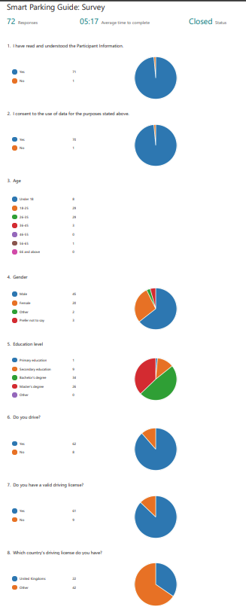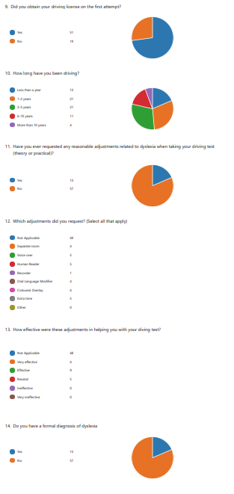
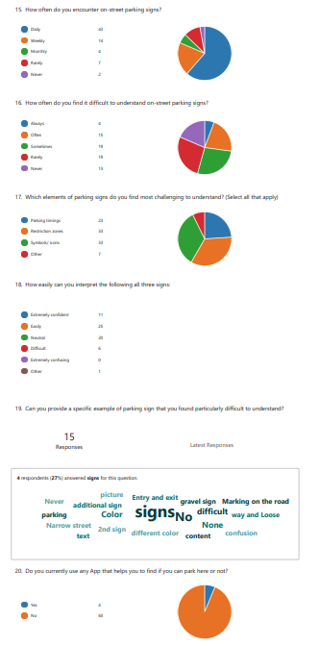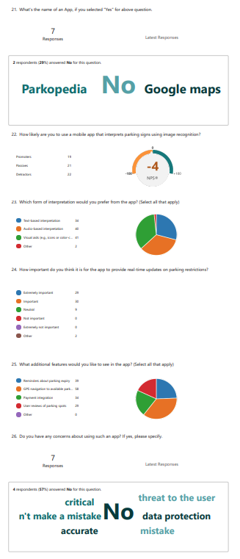

2.8.2 Code for Model build

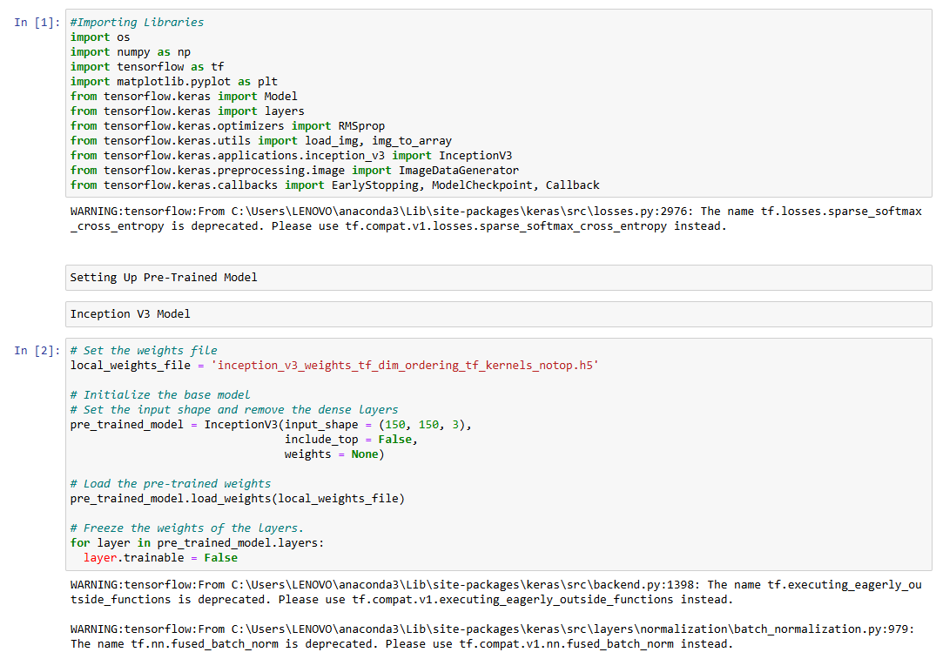
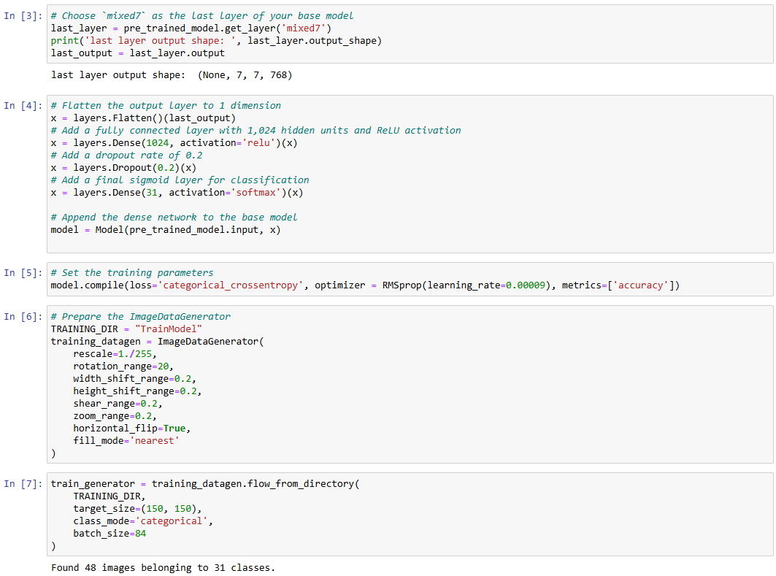
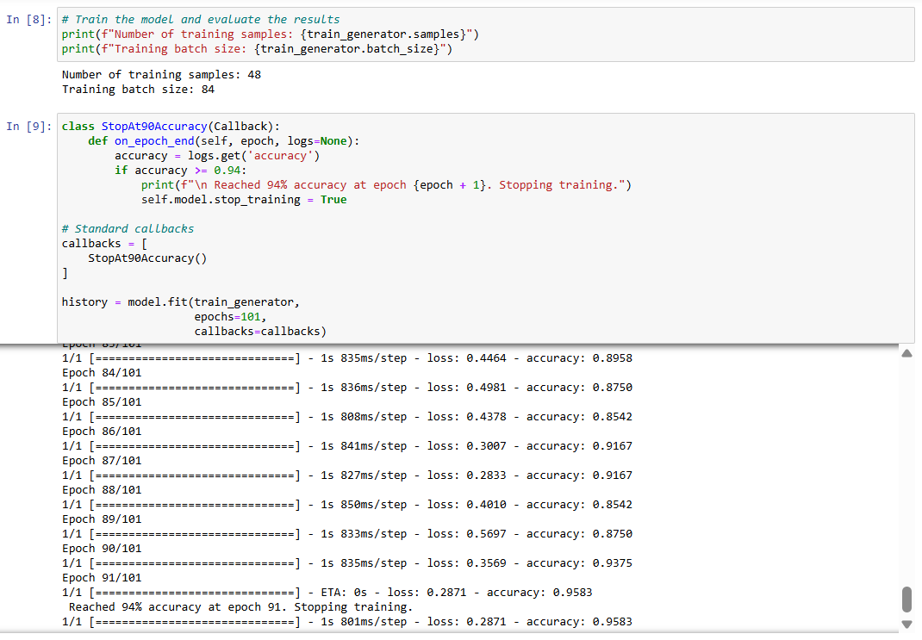
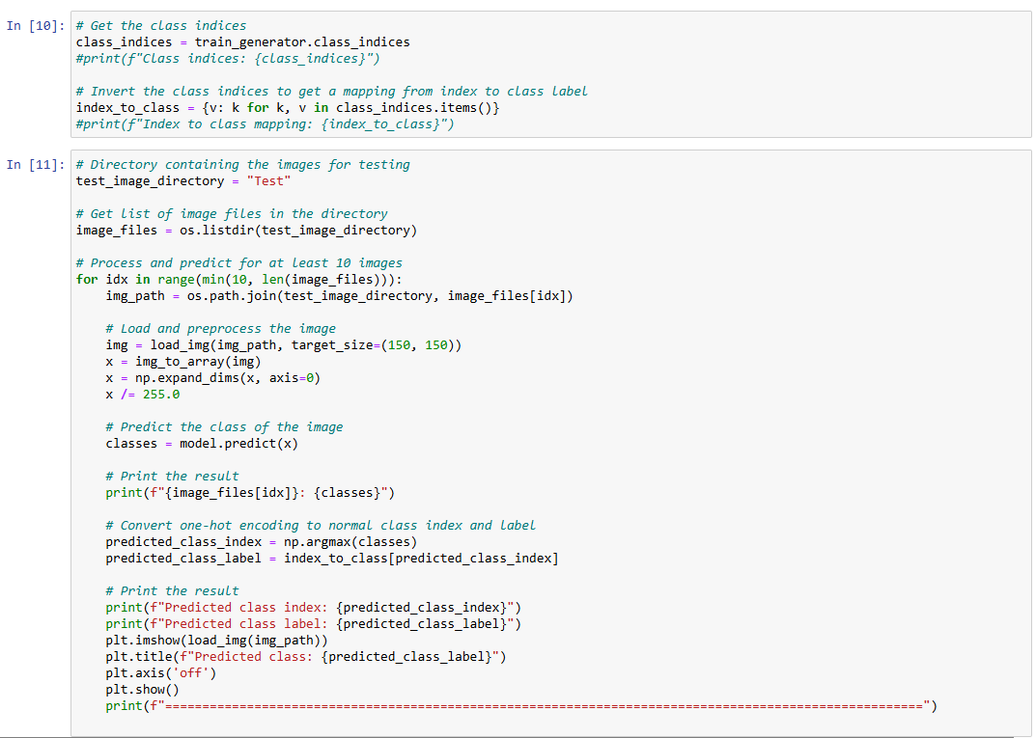
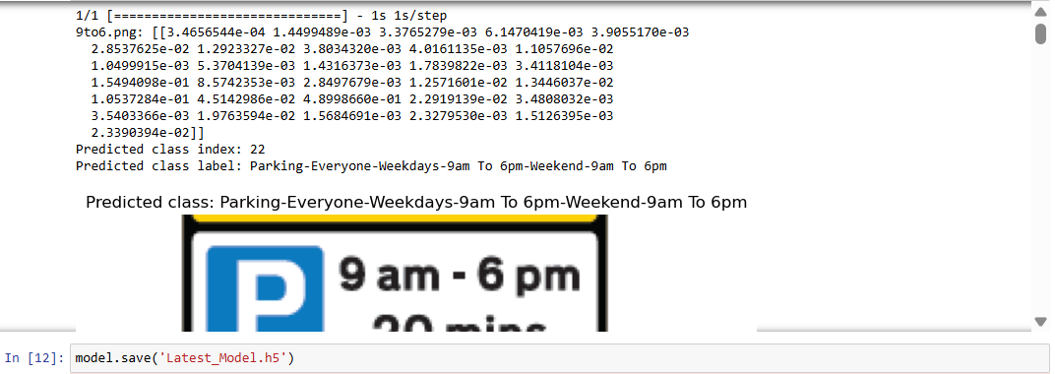

2.8.4 JSON Model File

https://raw.githubusercontent.com/eitikasharma/Model-Build/main/model.json

2.8.5 Five shard bin files

https://github.com/eitikasharma/Model-Build

2.8.3 Mobile App Code Link

https://github.com/eitikasharma/ParkingApp

2.8.4 Parking Sign Analysis
The following screenshots were taken at 8pm on Saturday (17 August,2024).


